Bank System
Muhammad Qasim Raza Arain
16053

Class Diagram
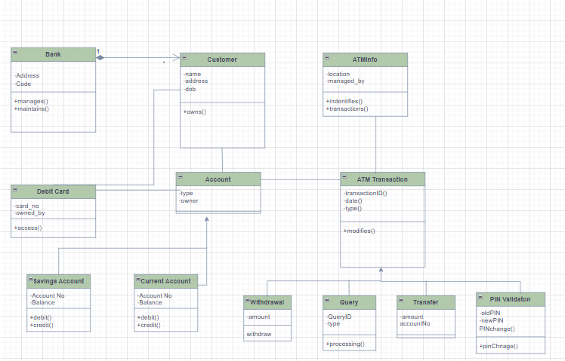

Code:
/***********************************************************************
* Module: BankingSystem
* Author: (UML Diagram Generator)
* Purpose: Defines all classes in the Banking System model.
***********************************************************************/

using System;
using System.Collections.Generic;
using System.Linq; // Included for potential future use (e.g., in transactions)

namespace BankingSystem
{
// --- Core Entities ---

/// <summary>
/// Represents the bank institution.
/// </summary>
public class Bank
{
// Attributes
public string Address { get; set; }
public string Code { get; set; }

// Association: A Bank manages/maintains many Customers
public List<Customer> Customers { get; set; } = new List<Customer>();

// Operations
public void Manages() { /* Implementation */ }
public void Maintains() { /* Implementation */ }
}

/// <summary>
/// Represents a bank customer.
/// </summary>
public class Customer
{
// Attributes
public string Name { get; set; }
public string Address { get; set; }
public DateTime Dob { get; set; } // Date of Birth

// Association: A Customer owns many Accounts
public List<Account> Accounts { get; set; } = new List<Account>();

// Operations
public void Owns() { /* Implementation */ }
}

/// <summary>
/// Represents a physical debit card linked to an account.
/// </summary>
public class DebitCard
{
// Attributes
public string CardNo { get; set; }
public string OwnedBy { get; set; }

// Association: Links to an Account
public Account LinkedAccount { get; set; }

// Operations
public void Access() { /* Implementation */ }
}

// --- Account Hierarchy ---

/// <summary>
/// Base class for all account types.
/// </summary>
public abstract class Account
{
// Attributes
public string Type { get; set; }
public string Owner { get; set; }

// Abstract members common to all accounts
public abstract string AccountNo { get; set; }
public abstract decimal Balance { get; set; }

// Operations
public abstract void Debit(decimal amount);
public abstract void Credit(decimal amount);
}

/// <summary>
/// Represents a customer's savings account.
/// </summary>
public class SavingsAccount : Account
{
// Attributes (Implements abstract properties)
public override string AccountNo { get; set; }
public override decimal Balance { get; set; }

// Operations (Implements inherited methods)
public override void Debit(decimal amount) { /* Withdrawal logic */ }
public override void Credit(decimal amount) { /* Deposit logic */ }
}

/// <summary>
/// Represents a customer's current (checking) account.
/// </summary>
public class CurrentAccount : Account
{
// Attributes (Implements abstract properties)
public override string AccountNo { get; set; }
public override decimal Balance { get; set; }

// Operations (Implements inherited methods)
public override void Debit(decimal amount) { /* Withdrawal logic */ }
public override void Credit(decimal amount) { /* Deposit logic */ }
}

// --- ATM and Transaction Logic ---

/// <summary>
/// Information specific to an ATM terminal.
/// </summary>
public class ATMInfo
{
// Attributes
public string Location { get; set; }
public string ManagedBy { get; set; }

// Operations
public void Indentifies() { /* Implementation */ }
public void Transactions() { /* Implementation */ }
}

/// <summary>
/// Base class for all ATM transactions.
/// </summary>
public abstract class ATMTransaction
{
// Attributes (Using read-only properties for ID, Date, and Type)
public abstract string TransactionID { get; }
public abstract DateTime Date { get; }
public abstract string Type { get; }

// Association: Transaction modifies an Account
public Account TargetAccount { get; set; }

// Operations
public void Modifies() { /* Implementation for modifying the account balance */ }
}

/// <summary>
/// Specific transaction for cash withdrawal.
/// </summary>
public class Withdrawal : ATMTransaction
{
// Attributes
public override string TransactionID => Guid.NewGuid().ToString();
public override DateTime Date => DateTime.Now;
public override string Type => "Withdrawal";

// Specific Operation
public void Withdraw() { /* Logic for cash dispensing */ }
}

/// <summary>
/// Specific transaction for balance inquiry.
/// </summary>
public class Query : ATMTransaction
{
// Attributes
public override string TransactionID => Guid.NewGuid().ToString();
public override DateTime Date => DateTime.Now;
public override string Type => "Query";

// Specific Attributes
public string QueryID { get; set; }
public decimal Amount { get; set; }

// Specific Operation
public void Processing() { /* Logic for retrieving and displaying balance */ }
}

/// <summary>
/// Specific transaction for transferring funds between accounts.
/// </summary>
public class Transfer : ATMTransaction
{
// Attributes
public override string TransactionID => Guid.NewGuid().ToString();
public override DateTime Date => DateTime.Now;
public override string Type => "Transfer";

// Specific Attributes
public decimal Amount { get; set; }
public string AccountNo { get; set; } // Destination account number
}

/// <summary>
/// Specific transaction for validating and changing a PIN.
/// </summary>
public class PINValidaton : ATMTransaction
{
// Attributes
public override string TransactionID => Guid.NewGuid().ToString();
public override DateTime Date => DateTime.Now;
public override string Type => "PIN Validation";

// Specific Attributes
public string OldPIN { get; set; }
public string NewPIN { get; set; }

// Specific Operations
public void PINchange() { /* Logic for validating and updating the PIN */ }
public void PINchnage() { /* Included the typo method from the diagram */ }
}
}

